**Introduction:**

Bangladesh cricket is one of the greatest prides for Bangladesh. Though Bangladesh cricket has advanced significantly in international level, unfortunately the domestic cricket management and maintenance has not been well-organized yet. Therefore, in spite of having lots of cricket loving talented players all over the country they are not inspired and utilized properly for sake of the Bangladesh cricket due to lack of seriousness and faulty system in the domestic cricket infrastructure. It is our belief that if we can improve this system to improve the domestic cricket infrastructure then no talent will be waste and our cricket will improve significantly.

**Subsystems:**

Our subsystems are:

* Program Management System
* Divisional Cricket Management System
* Game Education Management System
* Academy Operations Management System
* Coach Management System
* Control Management System

**Use-cases for Program Management System:**

**Actors:**

1. School representative

2. School Cricket Administrator.

3. Youth Cricket Administrator.

4. Facility and Equipment Administrator.

5. Program Manager.

**Use-case name & corresponding actors:**

|  |  |
| --- | --- |
| Use-case ID>>name | Actors |
| 1.1 Registration | School representative, School Cricket Administrator |
| 1.2 Arrange School Cricket Tournament | School Cricket Administrator, Program manager |
| 1.3 Arrange Youth Cricket Tournament. | Youth Cricket Administrator,  Program manager |
| 1.4 Update tournament info | Youth Cricket Administrator |
| 1.5 Ask for Facility and equipment. | School Cricket Administrator, Youth Cricket Administrator |
| 1.6 Provide Facilities | Facility and Equipment Administrator |

**Use-Case Diagram:**

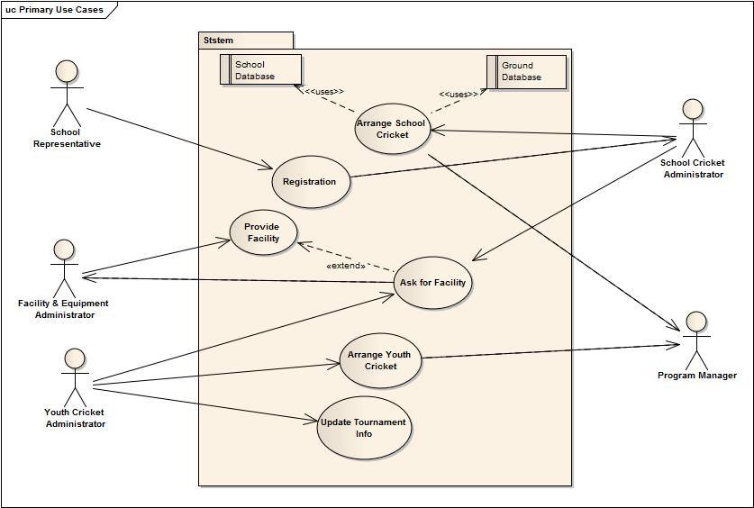

**Narratives and Typical Course of Events of Use-Case Names:**

* 1. **Registration**

Use Case ID: 1.1

Priority: High

Primary Actor: School Representative

Secondary Actor: School Cricket Administrator

Trigger: By School Representative.

**Typical Course of Events:**

* Fill up the form and submit it online.
* The system will forward it to school cricket administrator.
* The school cricket administrator will receive and check the form and accept it if it is okay.
* The system will enroll the school and save the info into the school database
* System will send an automatic confirmation email to the school.

**Documentation:**

* Conclusion: When the school entry is completed.
* Post-Condition: inform the school representative about the acceptance.
* Implementation: GUI will be provided in the webpage for the registration to fill up the form.

**1.2 Arrange School Cricket Tournament**

Use-case ID: 1.2

Priority: High

Primary Actor: School Cricket Administrator

Secondary Actor: Program manager

Precondition: School registration must be completed

Trigger: By School Cricket Administrator

**Typical Course of Events:**

* School Cricket Administrator will schedule the school tournament using the school database and ground database.
* The system will save the info and send it to Program manager.
* The program manager will approve the tournament proposal.
* The system will notify the acceptance to School Cricket administrator.

**Documentation:**

* Conclusion: concludes when the approval is made.
* Post-Condition: Inform the School Cricket Administrator about the approval.
* Implementation: GUI will be provided in the software the schedule platform and school database and ground database.

**1.3 Arrange Youth Cricket tournament.**

Use-case ID: 1.3

Priority: High.

Primary Actor: Youth Cricket Administrator

Secondary Actor: Program manager

Trigger: By Youth Cricket Administrator

**Typical Course of Events:**

* Youth Cricket Administrator will schedule the youth tournament using the District teams and Divisional teams’ database and ground database.
* The system will save the info and send it to Program manager.
* The program manager will approve the tournament proposal.
* The system will notify the acceptance to Youth Cricket Administrator.

**Documentation:**

* Conclusion: Concludes when the approval is made.
* Post-Condition: Inform the Youth Cricket Administrator about the approval.
* Implementation: GUI will be provided in the software the schedule platform and District teams and Divisional team’s database and ground database.

**1.4 Update tournament info**

Use-Case ID: 1.4

Priority: High

Actor: Youth Cricket Administrator

Trigger: Youth Cricket Administrator

**Typical Course of Events:**

1. Youth Cricket Administrator observes each match results and scorecard and stores it into the database.

**Documentation:**

* Conclusion: When database is stored.
* Post-Condition: Notify that information is successfully stored.
* Implementation: Provide a window to enter data.

**1.5 Ask for Facility Equipment**

Use-case ID: 1.5

Priority: High

Primary Actor: School Cricket Administrator, Youth Cricket Administrator

Secondary Actor: Facilities and Equipment Administrator

Precondition: School Cricket tournament Youth Cricket tournament must be scheduled.

Trigger: School Cricket Administrator or Youth Cricket Administrator.

**Typical Course of events:**

* School Cricket Administrator or Youth Cricket Administrator will list the necessary equipments and facilities and send it to facilities and equipment manager.
* The system will send it to facilities and equipment manager.

**Documentation:**

* Conclusion: When the request is sent.
* Post-Condition: Inform that the request is sent.
* Implementation: Provide a window in the software to enlist the facilities and equipments.

**1.6 Provide Facilities**

Use-case ID: 1.6

Priority: High

Primary Actor: Facilities and equipment manager.

Secondary actor: Program manager

Precondition: Request for facilities and equipments by School cricket administrator and youth cricket administrator

Trigger: Facilities and equipment manager.

**Typical Course of events:**

* The Facilities and equipment manager will see the request and approve and keep the database about the provided facilities.
* The system will provide the data.
* If the necessary equipment is not enough then the Facilities and equipment manager will inform the program manager about the shortage.
* The system will send a mail to program manager.

**Documentation:**

* Conclusion: When the acceptance mail is sent.
* Post-Condition: inform that the acceptance mail is sent and confirmation of email sent to the program manager if required.
* Implementation: Provide a window that will show the request of all necessary equipments and approve the request.

**Use-cases for Divisional Cricket Management System:**

**Actors:**

1. District Cricket Coach.

2. Divisional Cricket Coach.

3. Divisional Cricket Manager.

**Use-case name & corresponding actors:**

|  |  |
| --- | --- |
| **Use-case name** | **Actors** |
| 2.1 Form District Teams | District Cricket Coach |
| 2.2 Recommend Players | District Cricket Coach , Divisional Cricket Coach |
| 2.3 Form divisional Teams | Divisional Cricket Coach |
| 2.4 Assign Coaches | Divisional Cricket Manager |

**Use-Case Diagrams:**

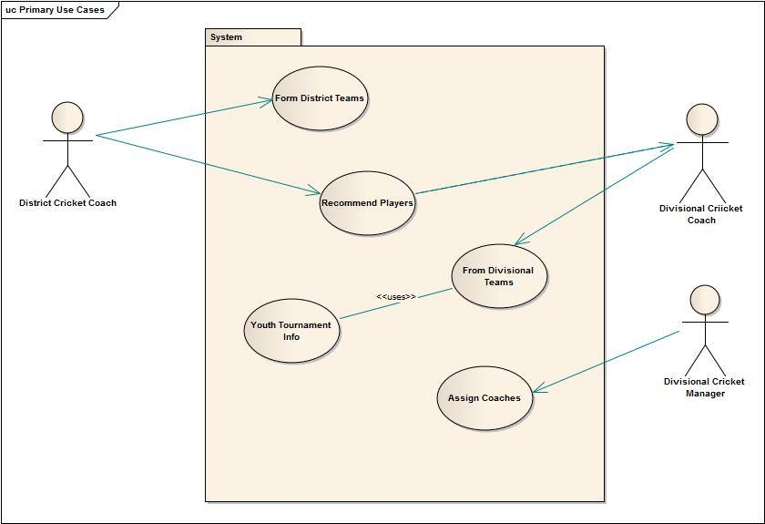

**Narratives and Typical Course of Events of Use-Case Names:**

**2.1 Form District Teams**

Use-case ID: 2.1

Priority: High

Primary Actor: District Cricket Coach.

Description: to form different aged teams of district level.

**Typical Course of Events:**

* Form district level aged teams and store their database.
* The system will save the database.

**Documentation:**

* Conclusion: When the entire database is saved in the system.
* Post-Condition: Notify that the database is saved
* Implementation: System will provide a window to store the database

**2.2 Recommend Players**

Use-case ID: 2.2

Priority: High

Primary Actor: District Cricket Coach

Secondary Actor: Divisional Cricket Coach

Description: To pass a Player into higher level

**Typical Course of Events:**

* District level coaches will send the information database about selective players for divisional team.
* The system will send the information to Divisional cricket coach.

**Documentation:**

* Conclusion: when request is sent.
* Post-Condition: Divisional cricket coach is notified
* Implementation: provided a window of recommendation for divisional team.

**2.3 Form Divisional Teams**

Use-case ID: 2.3

Priority: High

Primary Actor: Divisional Cricket Coach

Secondary Actor: Divisional Cricket Manager

Description: To form different age teams in divisional level

**Typical Course of Events:**

* Form divisional level aged teams and store their database.
* The system will save the database.

**Documentation:**

* Conclusion: when the database of divisional team is saved.
* Post-Condition: Notify that the database is saved.
* Implementation: System will provide a window to store the database.

**2.4 Name: Assign Coaches**

Use-case ID: 2.4

Priority: High

Primary Actor: Divisional Cricket Manager

Description: divisional cricket manager assign divisional and district level coaches

**Typical Course of Events:**

* Assign coaches for all district teams and inter their data.
* The system will save the data.

**Documentation:**

* Conclusion: when the district level coaches database is saved.
* Post-Condition: notify that the database is saved.
* Implementation: System will provide a window to store the database.

**Use-cases for Game Education Management System:**

**Actors:**

1. Game Education Deputy Manager.

2. Game Education Manager.

**Use-case name & corresponding actors:**

|  |  |
| --- | --- |
| Use-case name | Actors |
| 3.1 Maintain Educational Database. | Game Education Deputy Manager |
| 3.2 Assign Teacher. | Game Education Deputy Manager |
| 3.3 Monitor Educational Performance. | Game Education Deputy Manager |
| 3. 4 Assign Courses for Players. | Game Education Deputy Manager, Game Education Manager |

**Use-Case Diagrams:**

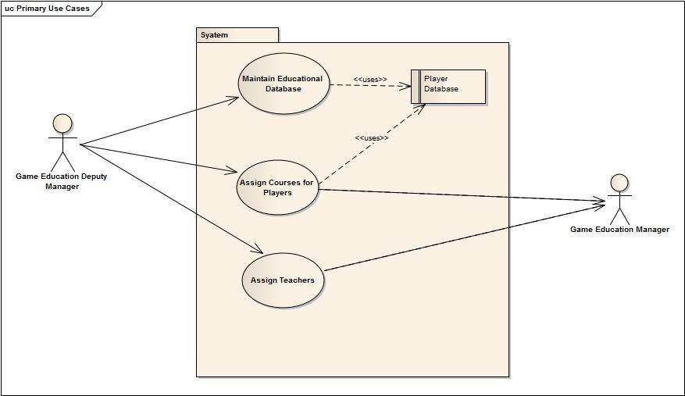

**Narratives and Typical Course of Events of Use-Case Names:**

**3.1 Maintain Educational Databases**

Use-case ID: 3.1

Priority: High

Primary Actor: Game Education Deputy Manager

Trigger: Game Education Deputy Manager

**Typical Course of Events:**

1. Update the database regularly

2. System will save the data.

**Documentation:**

* Conclusion: When database is saved.
* Post-Condition: Notify that information is successfully stored.
* Implementation: Provide a window to enter data.

**3.2 Assign Teachers**

Use-case ID: 3.2

Priority: High

Primary Actor: Game Education Deputy Manager

Description: Assign teachers for different courses for academy players

**Typical Course of Events:**

1. Assign course teacher for the players by game education deputy manager and update their database.
2. The system will save the information.

**Documentation:**

* Conclusion: When assigned course teachers’ database is saved.
* Post-Condition: Notify that the Course teachers are assigned and their database is saved.
* Implementation: Provide a window to save the teachers database for respective courses.

**3.3. Monitor Educational Performance**

Use-case ID: 3.3

Priority: High

Primary Actor: Game Education Deputy Manager

Precondition: game education deputy manager must have the updated information’s of educational performance of players

**Typical Course of Events:**

1. Monitor player’s educational performance and decide if they need any course or teacher.

2. If needed, he will inform it to Game Education Manager.

3. The System will send the request to Game Education manager.

4. Update the Educational Performance of a player.

5. The system will save the information.

**Documentation:**

* Conclusion: When notification of updates of players educational performance is sent.
* Post-Condition: confirmation of that the request is sent
* Implementation: provide a window to show the updates of player’s educational performance and send it to update the player’s database.

**3.4. Assign Courses of Players**

Use-case ID: 3.4

Priority: High

Primary Actor: Game Education Manager

Secondary Actor: Game Education Deputy Manager

Precondition: Game education deputy manager must have the player database

**Typical Course of Events:**

1. Evaluate players educational database and determine Which courses are needed for a player and assigned.

3. Send all updates to game education manager

**Documentation:**

* Conclusion: when all updates are sent.
* Post-Condition: confirmation that the required courses are assigned and updates are sent.
* Implementation: provide a window that will show the courses assigned to the players individually.

**Use-Cases for Academy Operations Management System:**

**Actors:**

1. Academy Operation Manager.

2. Operation Manager.

**Use-case name & corresponding actors:**

|  |  |
| --- | --- |
| Use-case name | Actors |
| 1. Observe Players Lacking. | Academy Operation Manager,  Operation manager |
| 2. Assign Head-coaches. | Academy Operation Manager,  Operation manager |

**Use-Case Diagrams:**

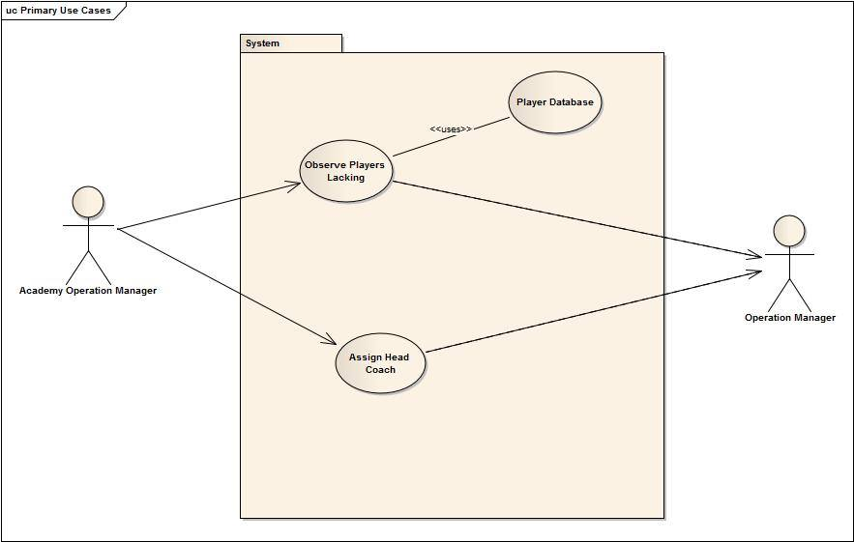

**Narratives and Typical Course of Events of Use-Case Names:**

**4.1. Observe players lacking**

Use-case ID: 4.1

Priority: High

Primary Actor: Academy Operation Manager

Precondition: Academy operation manager must have the player database.

**Typical Course of Events:**

1. Observe player skills and lacking using the players’ databases
2. If a player needs extra Lesson then Academy operations manager will notify it to Operation manager.
3. The System will forward the mail to Operations Manager.
4. The operations manager sends a feedback of this event to Academy Operations manager.

**Documentation:**

* Conclusion: when observation of players database is completed.
* Post-Condition: confirmation of observation is completed.
* Implementation: provide a window to only show the players lacking and skills.

**4.2. Assign Head Coach**

Use-case ID: 4.2

Priority: High

Primary Actor: Academy Operation Manager

Precondition: Academy Operation Manager must have Coach databases.

**Typical Course of Events:**

**1.** Observe coaches database to assign coach.

**2.** Maintain database of assigned coach.

**Documentation:**

* Conclusion: When the database of assigned coach is saved.
* Post-Condition: Confirmation that the database of assigned coach is saved.
* Implementation: provide a window to store the data of assigned coach.

**Use-cases for Coach Management System:**

**Actors:**

1. **Manager-Coach.**
2. **Operation Manager.**

**Use-case name & corresponding actors:**

|  |  |
| --- | --- |
| Use-case name | Actors |
| 1. Maintain all academy coaches. | Manager-Coach |
| 2. Maintain all academy teams. | Manager-Coach |
| 3. Notify | Manager-Coach, Operation Manager |

**Use-Case Diagrams:**

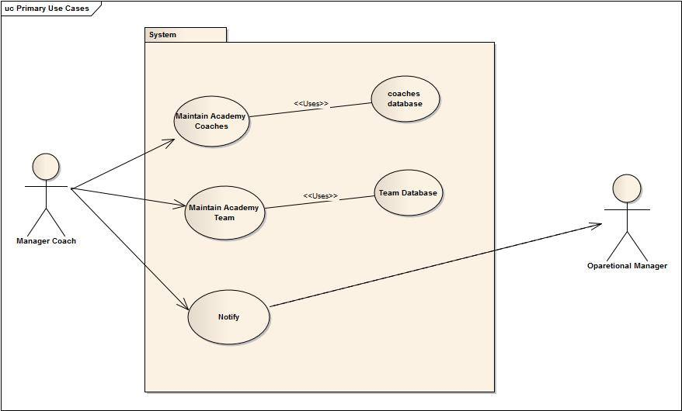

**Narratives and Typical Course of Events of Use-Case Names:**

**5.1: Maintain All Academy Coaches**

Use-Case ID: 5.1

Priority: High

Primary Actor: Manager Coach

Precondition: Manager Coach must have the database of academy coaches

**Typical Course of Events:**

1. Observe all academy coaches database.
2. Updates academy coaches’ database.

**Documentation:**

* Conclusion: when observation is done.
* Post-Condition: Confirmation that the observation and update is complete.
* Implementation: provide a window to show and update the academy coaches’ database.

**5.2: Maintain All Academy Teams**

Use-Case ID: 5.2

Priority: High

Primary Actor: Manager Coaches

Precondition: manager coaches must have the academy teams’ database

**Typical Course of Events:**

1. Observe the database of all academy or national level teams.
2. Make necessary updates of teams’ database.

**Documentation:**

* Conclusion: when observation is done.
* Post-Condition: Confirmation that the observation and update is complete.
* Implementation: provide a window to show and update the academy coaches database.

5.3: **Notify**

Use-Case ID: 5.3

Priority: High

Primary Actor: Manager Coach

Precondition: Manager Coach must have the database of academy coaches and teams.

**Typical Course of Events:**

1. Send an email to operations manager notifying all the updates.

**Documentation:**

* Conclusion: when mail is sent.
* Post-Condition: confirmation that the mail is sent.
* Implementation: GUI will be provided in the webpage to send the mail.

**Use-cases for Control Management System:**

**Actors:**

1. Operation Manager.
2. National Manager.

**Use-case name & corresponding actors:**

|  |  |
| --- | --- |
| Use-case name | Actors |
| 6.1 Observe all Subsystem. | Operation Manager |
| 6.2 Notify | Operation Manager, National Manager |
| 6.3 Contact BCB | National Manager |

**Use-Case Diagrams:**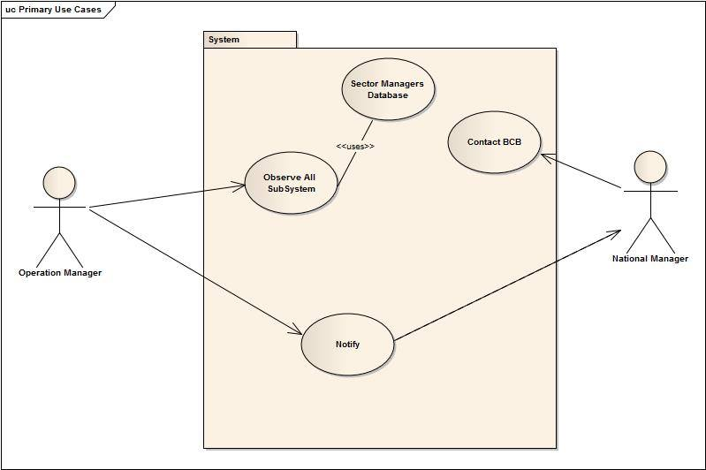

**Narratives and Typical Course of Events of Use-Case Names:**

**6.1 Observe all subsystems**

Use-case ID: 6.1

Priority: High

Actor: Operation manager

Precondition: The databases of all the administrators must be sent.

**Typical Course of events:**

1. Operation manager gets regular updates from all the managers
2. Operation manager updates all the managers’ database
3. Operation manager observes their database

**Documentation:**

* Conclusion: When updates are completed.
* Post-Condition: Confirmation that updates and observation is finished.
* Implementation: Provide a window to show and update all managers database.

**6.2 Notify**

Use-case ID: 6.2

Priority: High

Actor: Operation manager

Precondition: Operation manager must get all the necessary updates and databases from his working managers

**Typical Course of events:**

1. Operation manager sends an email notifying everything (financial updates, officers’ databases, etc) to the national manager

**Documentation:**

* Conclusion: When mail is sent
* Post-Condition: Confirmation that the mail is sent.
* Implementation: provide a window to send the mail.

**6.3 Contact BCB**

Use-case ID: 6.3

Priority: High

Actor: National manager

Precondition: National manager must get all the necessary updates and databases from his working managers

**Typical Course of events:**

1. National manager maintains contact with BCB by delivering necessary updates via mail.

**Documentation:**

* Conclusion: When Mail is sent.
* Post-Condition: Confirmation that the mail is sent.
* Implementation: Provide a window to send mail.

**Conclusion:**

In short Our Objective is to help BCB to prosper so that our cricket and the cricketers will prosper as well. This also helps all the domestic cricket players to have their opportunities to show their skills. We are very hopeful that, if we are able to automate the game development committee, then the whole Bangladesh Cricket Board will be benefited.